Vizard practicum week 5 B
Course: VR3d
Version: 1.1
Author: Michael Schifferling
Patrick de Beer (Unity add-on)

Introduction:
In this practicum we will continue with light sources and materials.
Today’s highlight ( ) will be adding specular lighting to the shader.
We will also take a look at how to add fog to our scenes.

Assignment: Add Specular Lighting
In this assignment, we add specular light to the project of 5A.
Just for fun, replace the sphere by the Buddha model: "buddha1.3DS". Adjust the scaling so the figure looks right.

Step 1: Pass parameter to the shader
Specular lighting calculations need a uniform variable to determine the shininess of the material.
Pass a float value “shininess” as uniform parameter from the Vizard project to the vertex shader (start with value 10).
Also pass a uniform variable that defines the specular color of the light (make it white to start with).

Step 2: Implement vertex shader function CalculateSpecularColor, using the Blinn-Phong formula in the slides of 2A:
vec4 CalculateSpecularColor(vec3 normalinEyeSpace, vec4 vertexInEyeSpace,
vec4 lightPositionInEyeSpace, float shininess,
vec4 lightSpecColor, vec4 objectSpecColor)

This functions determines the highlights of objects. It depends on the viewing angle and the halfvector H between the lightsource and the viewer. You can use the following code to calculate H:
vec3 vertexInEyeSpace3 = vec3(vertexInEyeSpace) / vertexInEyeSpace.w;
vec3 lightPositionInEyeSpace3 = vec3(lightPositionInEyeSpace) / lightPositionInEyeSpace.w;
vec3 lightDirection = lightPositionInEyeSpace3 - vertexInEyeSpace3;
float lightDistance = length(lightDirection);
lightDirection = normalize(lightDirection);

//The 'eye' is at the vertex projected in eye space.
vec3 eyeDirection = normalize(-vertexInEyeSpace3);

//The halfvector is the reflection between lightdirection vector and eye vector.
vec3 halfVector = normalize(lightDirection + eyeDirection);
Use the pow() function for calculating the exponent.
Use the lightDistance calculated above to calculate the attenuation, as you did for the diffuse light.

Step 3: Add a varying variable specularColor.
Step 4: Add code to the main function of your vertex shader that calls the CalculateSpecularColor and assign the specular color to the varying variable specularColor.
Take the lightSpecColor and shininess from the uniform variables you added in step 1; use white vec4(1.0,1.0,1.0,1.0) for the objectSpecColor.
Step 5: Adjust the fragment shader to take the specular color into account.

Result
When all is done and the project is started, you’ll see something like this (it should look ‘shiny’):
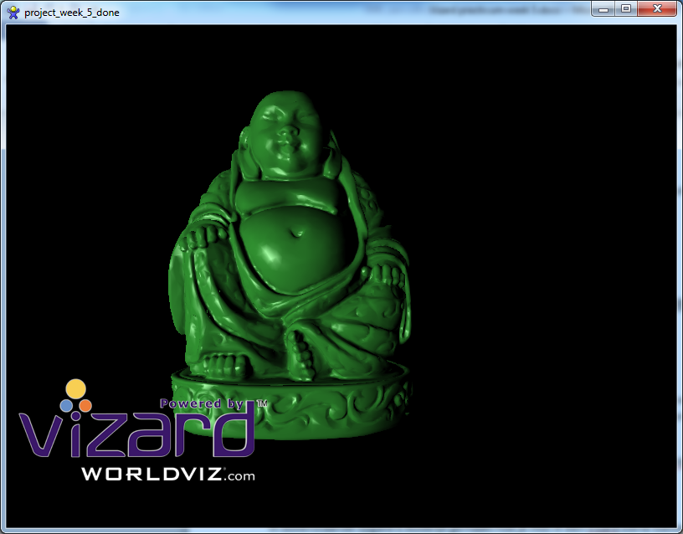

Assignment: Fog in Vizard.
Fog can be easily added to Vizard by using viz.Fog().
For more information about Vizard fog, take a look at the Vizard help:
reference->scenes->adding fog.

Create a new Vizard project, and add multiple objects to the scene. The distance to the camera should be different for these objects (some closer by, some further away). At least 2 objects should be animated, moving closer to the camera and further away.
Now add fog to the scene. Use a viz.KEYDOWN_EVENT to toggle between:
- Linear fog
- Exponential fog
- No fog

Assignment:Fog using Shaders
In the previous assignment it was shown how to add simple fog in Vizard.
Now it’s time to create your own fog in shader code.
You can use the same shader code from the specular lights assignment and expand it with fogging calculations.
Start by adding some uniform parameters to control the fog settings:
- uniform float fogStart
- uniform float fogEnd
Pass the following values from Vizard to the shader:
- fogStart = 0.1
- fogEnd = 10.0
The fog intensity is determined by the distance between the camera(eye) and the vertex.
This distance can be calculated by finding the length of the vertexInEyeSpace3 vector.
Use the glsl function : length(vector)

Calculate the final fog intensity with the following formula:

fogFactor = (fogEnd – eyeDistance) / (fogEnd – fogStart) .
Finally multiply the colors(ambientColor, diffuseColor, specularColor) with this factor.

Unity practicum week 5b

Instructional Links
none

Assignment: Create your own specular lighting shader
Specular lighting is the bright, shiny spots that appear on smoother surfaces. Usually they are the color of the light, but occasionally will take on a component of the material they are reflecting off of. The specular highlight moves around, depending on where the viewer is, as well as where the light is.
In Unity there is already a built-in shader on the material properties pane, but we are going to define our own one for a good understanding of what is going on under the hood and a little bit the math that is involved.
You can follow similar instructions as written for the Vizard environment.

Assignment: Add Fog to your scene
Adding a fog effect in Unity can be easily done in the rendersettings pane (Edit->Rendersettings). This applies fog to all your scenes.
In scripting the same properties can be directly manipulated.
http://docs.unity3d.com/ScriptReference/RenderSettings.html
Create a new scene, and add multiple objects to the scene. The distance to the camera should be different for these objects (some closer by, some further away). At least 2 objects should be animated, moving closer to the camera and further away.

Now add fog to the scene via scripting and use an Input.GetKeydown() to toggle between:

- Linear fog
- Exponential fog
- No fog

Assignment: Create your own fog shader
The above thing can also be done in your own customized shader. Advantages is that you can add behavior that is not offered with the default scripting. Also it will let you understand better what is actually going on for fog rendering.
You can use the same shader code from the specular lights assignment and expand it with fogging calculations.
Start by adding some uniform parameters to control the fog settings:
- uniform float fogStart
- uniform float fogEnd
Pass the following values from Vizard to the shader:
- fogStart = 0.1
- fogEnd = 10.0
The fog intensity is determined by the distance between the camera(eye) and the vertex.
This distance can be calculated by finding the length of the vertexInEyeSpace3 vector.
Use the glsl function : length(vector)

Calculate the final fog intensity with the following formula:

fogFactor = (fogEnd – eyeDistance) / (fogEnd – fogStart) .
Finally multiply the colors(ambientColor, diffuseColor, specularColor) with this factor.

Useful Unity concepts in this practicum
Objects: RenderSettings, Input

